Lab 8 Prelab

**Name**: Chimzim Ogbondah

**Lab Partner or Team Member Name(s) (if you worked together and are submitting the same document or mostly the same answers):**

**Lab Section**: 1

**Submit your prelab document as a PDF file in Canvas under the corresponding prelab assignment. Every student submits their own prelab. Lab partners/teams are allowed to work on the prelab together and submit the same document (if there is actual collaboration on the document). Text responses should be typed or printed neatly.**

1. System sketch

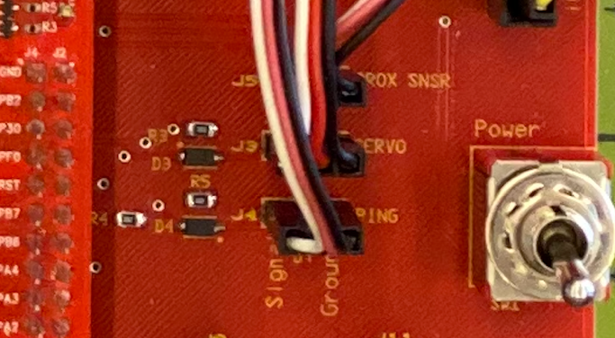Similar to system sketches in previous labs, sketch a diagram that shows how the servo motor connects to the microcontroller. Refer to the file Cybot-Baseboard-LCD-Schematic.pdf, as needed. In the photo of the CyBot baseboard, shown at right, the jumper wires are connected to the sensors and servo motor.

Your diagram should show the port and the pin (or bit) number of the port that the servo is connected to. Give the port name and pin number used in the microcontroller (e.g, Port A pin 0, PA0).

1. How do you know that the pin the servo is connected to (question 1) corresponds to Timer 1B in the microcontroller? Be specific in your explanation.
   1. GPIO port B pin 5 which is connected to the Servo Sensor its analog function 7 is T1CCP1. If you look up T1CCP1 in the timer data sheet it corresponds with Timer 1B.
2. Write two lines of code to configure the GPIOAFSEL and GPIOPCTL registers to select the Timer 1B (T1CCP1) peripheral signal as an alternate function for the GPIO pin it is connected to.  
   GPIO_PORTB_AFSEL_R |= 0x20;

GPIO_PORTB_PCTL_R = GPIO_PORTB_PCTL_R & ~(0xF000)) | 0xD000

1. Refer to the GPTM Timer register list, such as in [GPIO-GPTM-registers-tables.pdf](https://canvas.iastate.edu/courses/69323/files/10454232/download?wrap=1).
   1. Which GPTM register enables PWM mode?
      1. GPTMTBMR
   2. What is the memory address of this memory-mapped I/O register?
      1. 0x4003.1000
   3. Sketch the register as shown in the datasheet description. Circle the bit or bit fields that must be set up for this lab.
      1. Ignore the As in the other register names I copied down the bit fields based on the wrong register, then switched to the right one. The bits we need to modify for the lab are labeled correctly

1. Suppose you are outputting a PWM signal having a period of 20 milliseconds. Using a 16 MHz system clock, how many clock periods (or timer steps) are needed for the period? State your result in both decimal and hex.
2. **Optional** (Bonus): Suppose you don’t have the actual servo motor installed yet, but you have been writing some code and want to test your code without the servo. You wrote test code that uses a GPTM timer (PWM mode) to generate a PWM signal on a GPIO port pin. Briefly describe how you could run your test code without a servo to verify it works. In other words, how might you observe the output signal generated by your program? (2 points)

* You could have the GPIO port pin be active if it is getting a signal that would go to the servo…this would allow you to know that your program is running properly or at least sending data.